**Web Development project report on**

**HOTEL MANAGEMENT SYSTEM.**

A Project Report submitted in partial fulfillment for the award of

MBA (Fintech)

**Submitted by**

A.BALAJI

K.AMMAN NAIDU

Regd No: 121923901002

Regd No: 121923901004

Under the guidance of

Mr. Divakar Allavarapu

Assistant Professor



**DECLARATION**

We, the undersigned, hereby declare that, the project titled “Web Development Project report on School Education Management System” submitted to GITAM Institute of Management, GITAM University for the award of the Masters of Business Administration (Fintech) is the original work done by us, under the guidance of Mr. Divakar Allavarapu, Assistant Professor, GITAM Institute of Management. The empirical findings in this report are based on the data collected by us. It was not copied from any other project. The project has not been submitted to any Substitute/University for the award of any Diploma/Degree.

Date: 14-04-2020 A.BALAJI (121923901002)

Place: Visakhapatnam K.AMMAN NAIDU (121923901004)

**CERTIFICATE**

This is to certify that the project entitled, “Web Development Project report on School Education Management System”, is a bonafide work done by A.BALAJI(121923901002), K.AMMAN NAIDU(121923901004) and is submitted in partial fulfilment for the Masters of Business Administration (Fintech) of GITAM University. It has not been submitted for the award of any diploma/degree in any other Institution/University.

Date: 14-04-2020 Mr. Divakar Allavarapu

Place: Visakhapatnam Assistant Professor

**ACKNOWLEDGEMENT**

We thankful to Prof. Sheela, Principal, GITAM Institute of Management, GITAM University, Vishakhapatnam, for giving us an opportunity to learn and have a study on very important topic of management. We are thankful to Mr. Divakar Allavarapu the project guide who helped us and guided us in completing this project. We are immensely thankful to friends and the respondents who have guided us at every stage in preparing and finishing this project with their valuable suggestions.

A.BALAJI (121923901002)

K.AMMAN NAIDU (121923901004)

**CONTENTS Page No**

1. Introduction 06
2. Executive Summary 07
3. Execution Procedure 07
4. Source Code 11
5. Some Snippets Of Web Site 12-20
6. Conclusion 20
7. References 20
8. **INTRODUCTION: -**

HTML (the Hypertext Mark-up Language) and CSS (Cascading Style Sheets) are two of the core technologies for building Web pages. HTML provides the structure of the page, CSS the (visual) layout, for a variety of devices. Along with graphics and scripting, HTML and CSS are the basis of building Web pages and Web Applications.

**About HTML: -**

HTML is the standard mark-up language for creating Web pages.

* HTML stands for Hyper Text Mark-up Language
* HTML describes the structure of a Web page
* HTML consists of a series of elements
* HTML elements tell the browser how to display the content
* HTML elements are represented by tags
* HTML tags label pieces of content such as "heading", "paragraph", "table", and so on

Browsers do not display the HTML tags, but use them to render the content of the page

**About CSS: -**

CSS stands for Cascading Style Sheets

* CSS describes how HTML elements are to be displayed on screen, paper, or in other media
* CSS saves a lot of work. It can control the layout of multiple web pages all at once
* External stylesheets are stored in CSS files
* It handles the look and feel part of a web page. Using CSS, you can control the color of the text, the style of fonts, the spacing between paragraphs, how columns are sized and laid out, what background images or colors are used, layout designs,variations in display for different devices and screen sizes as well as a variety of other effects

**About Xaamp: -**

XAMPP is a software distribution which provides the Apache web server, MySQL database (actually Maria DB), Php and Perl (as command-line executables and Apache modules) all in one package. It is available for Windows, MAC and Linux systems. No configuration is necessary to integrate Php with MySQL.

It provides a relatively painless installation and way to manage the configuration changes. Also provided is PhpMyadmin which gives a GUI tool for managing your MySQL databases.

The XAMPP download site which I use is:

<https://www.apachefriends.org/>

1. **Executive Summary**

Project was designed with the objective to create a database of students and faculty for an education system with a user interface using HTML and PHP languages. The web pages were designed using HTML script and CSS language was used to enhance the user experience. Various forms were designed to take details about students and faculty from the administrator. Once the details were received from the user, PHP script was used to send and store that data in a database. Apache server was used to host the database and SQL queries were used to store and retrieve the data from the database.

1. **Execution procedure**
2. Copy the html and php files in the htdocs folder of xampp folder.
3. Open xampp control to launch apache server and sql database.
4. Create relevant tables in the sql database according to the created forms.
5. After launching the server successfully, go to php/myadmin in the web browser.
6. In the php/myadmin page navigate to a folder containing html and php files of the **hotel management system.**
7. Open **generalhome.php** to launch the website for the hotel system and to have administrator privileges to enter information, provide username and password.

**SQL TABLES:**

In Sql we created 6 tables:

|  |  |
| --- | --- |
| **TABLES** | **ATTRIBUTES** |
| admin | Username, password |
| cancellation | Canid,canceldate,bookingdate,resid,userid,fullname,gender,roomid,location  , roomtype, checkin ,checkout ,members ,amoun ,payment, balance |
| comments | Sno,name,email,text,datesub |
| reservationtable | bookingdate,resid,userid,fullname,gender,roomid,location  , roomtype, checkin ,checkout ,members ,amoun ,payment, balance |
| room | rid,roomid,location,roomtype,price |
| usertable | Userid,fullname,gender,email,phonenumber,address,idproof,username,  password |

**GENERAL HOME PAGE:**

* To see general content of hotel.
* USER SIDE.-check for availability, book hotel rooms, submit reviews, cancel the room
* ADMIN SIDE.-check for total no rooms in each hotel, can add extra room, can we the booked rooms. Can see the comments of user.

1. **Source Code: -**

**css**



**User PHP files:**



**Admin PHP files:**



**Images:**



1. **SOME SNIPPETS OF WEBSITE:**

General home page containing menus (HOME,SERVICES,CONTACTUS,BOOKING,ADMIN)

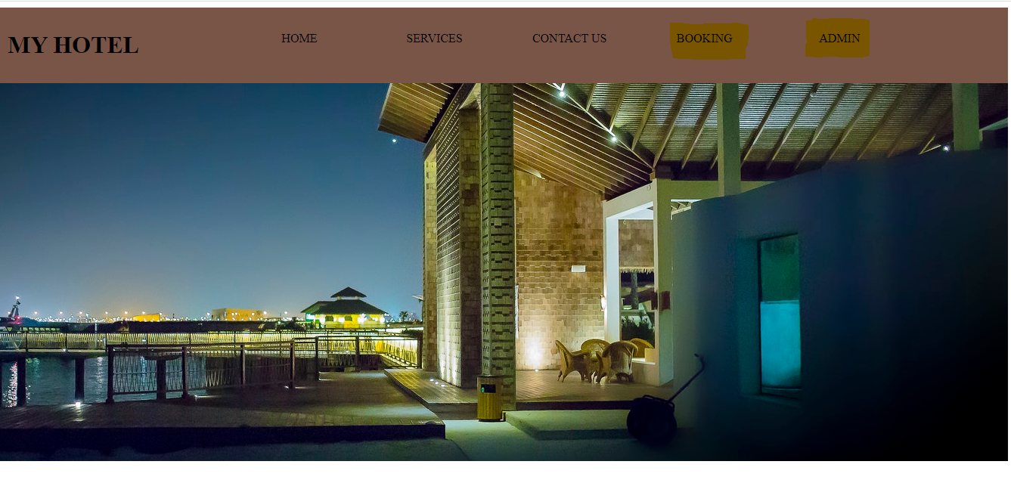

USER login and registration page:intially user will register and then login into the website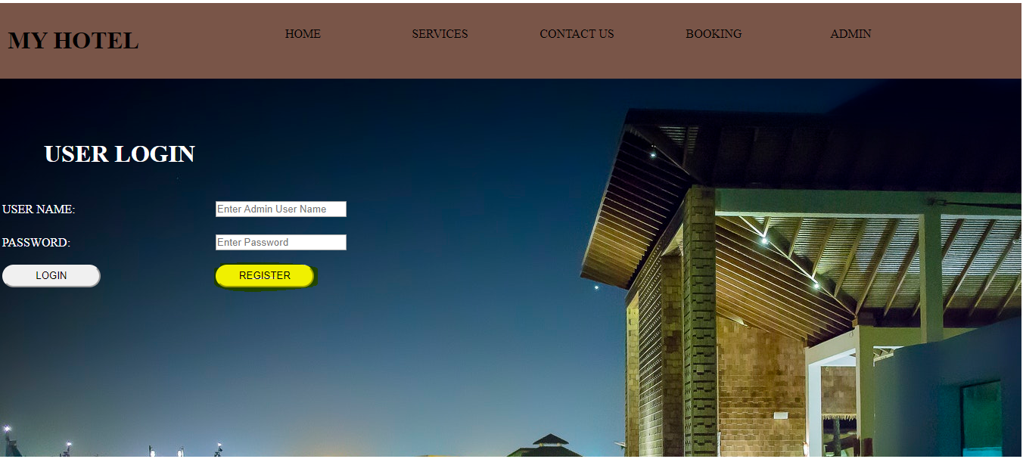

USER registration page for first time users

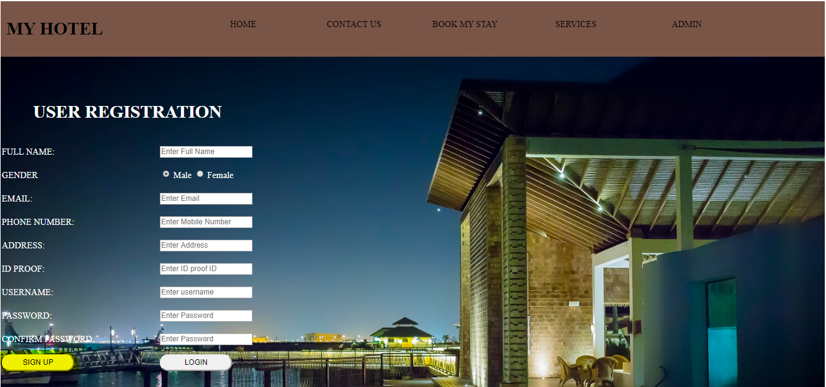

Login page for already registered customers:

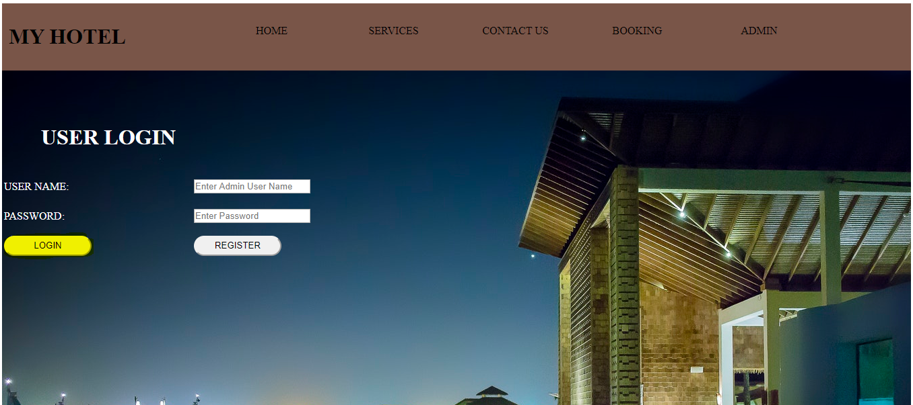

After login user home page where he can check the availability suitable for his requirements.

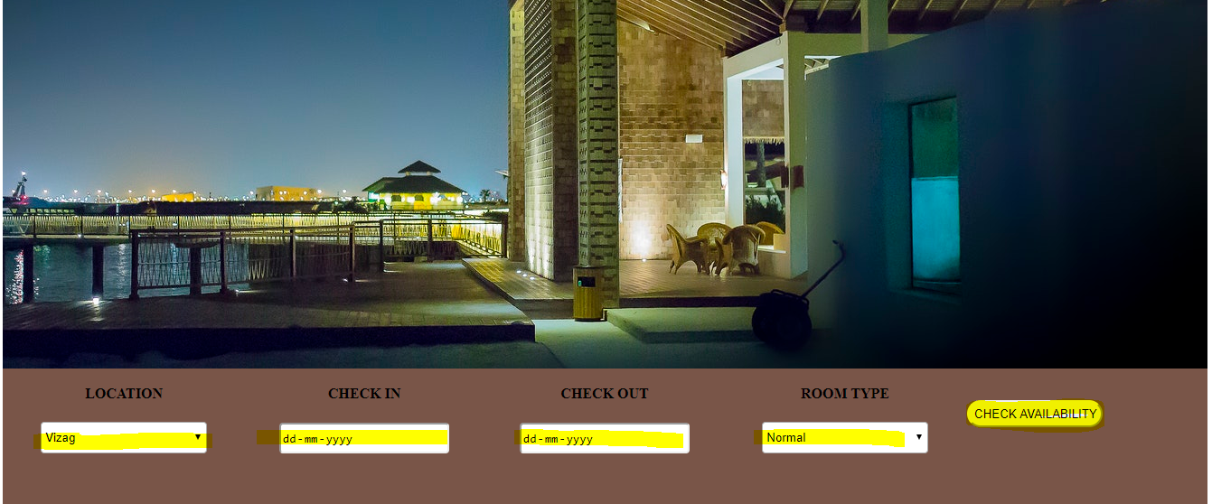

If rooms are not available it show the below page

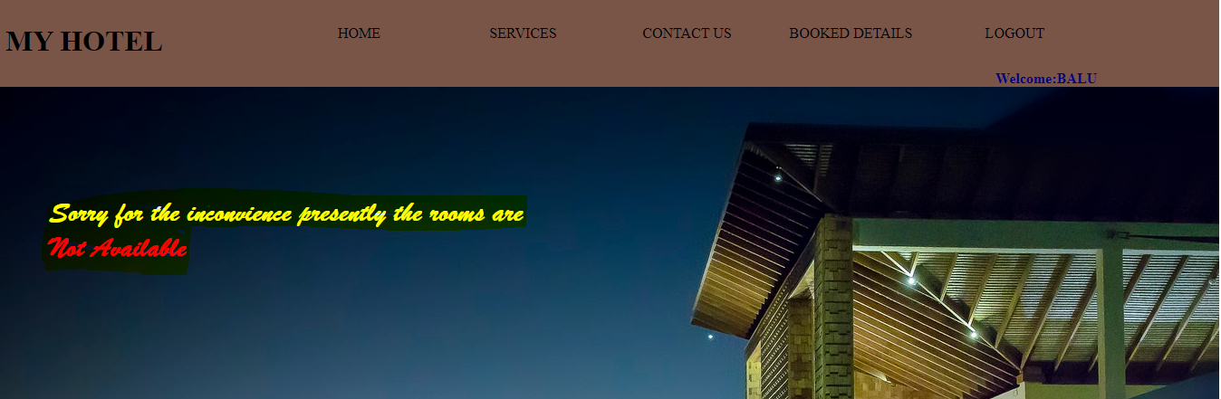

If available user will be shifted to the other page where he can check the details and chose the payment option online or cash

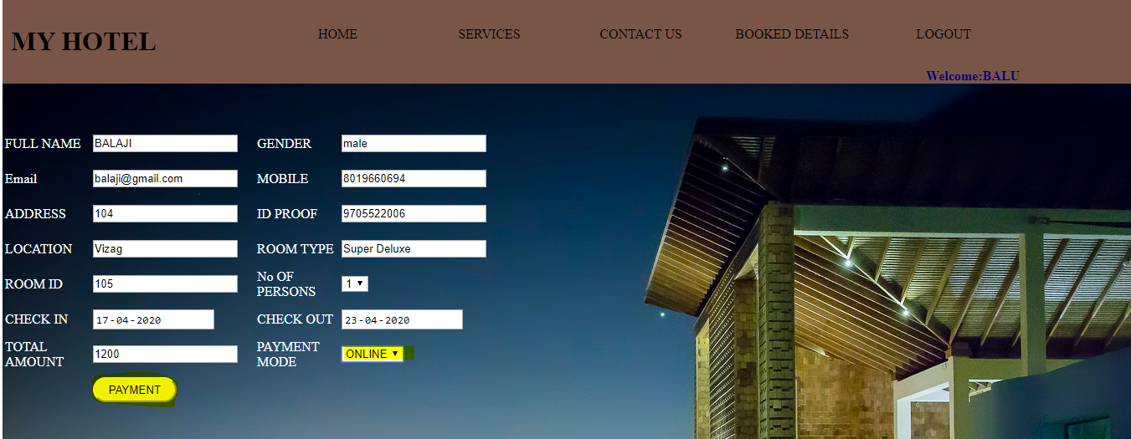

Payment page he can pay through online

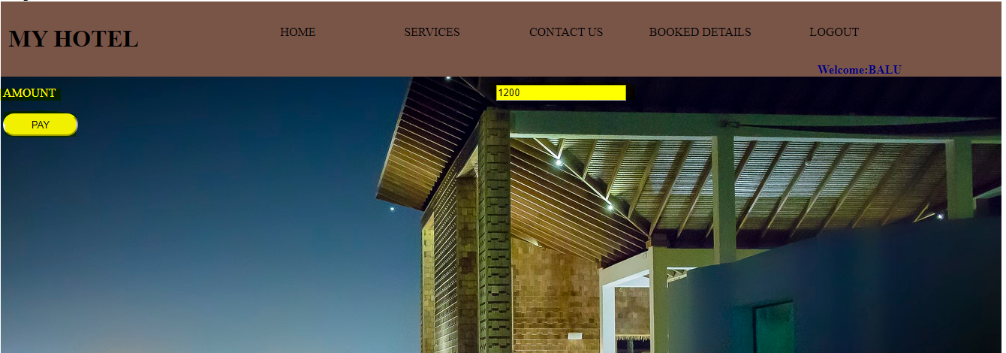

If it is Cash

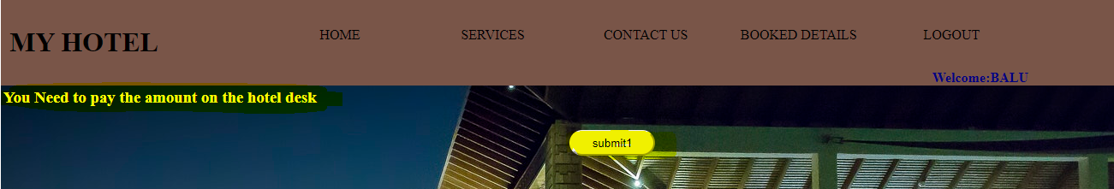

Booked History and Cancellation

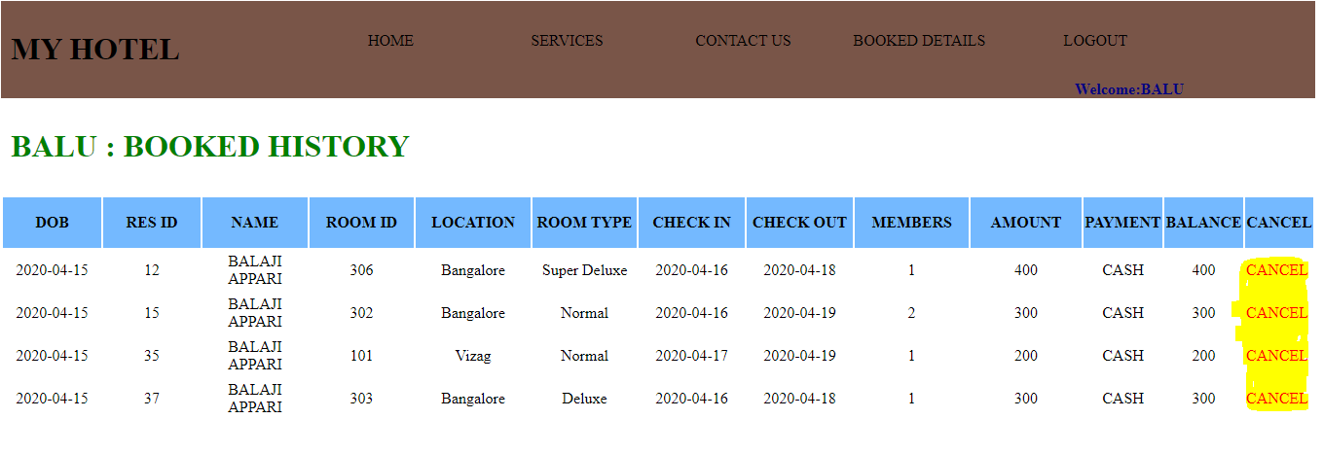

Comments and review page of user

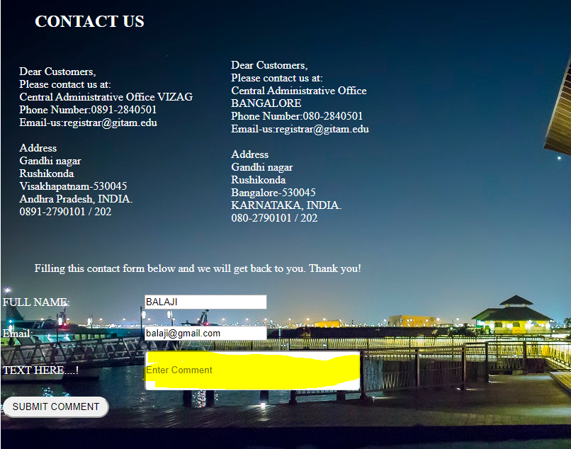

Services page

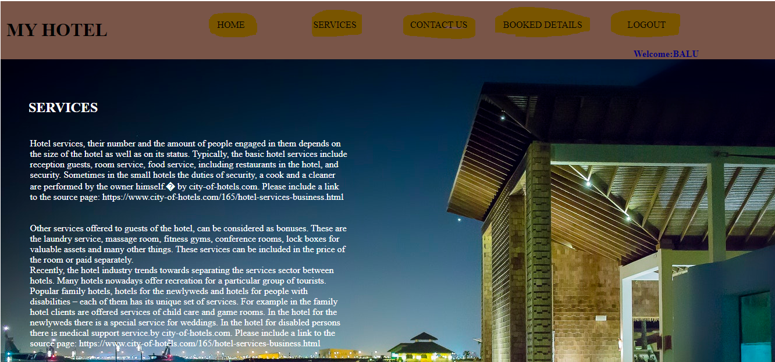

**ADMIN SIDE:** Login page

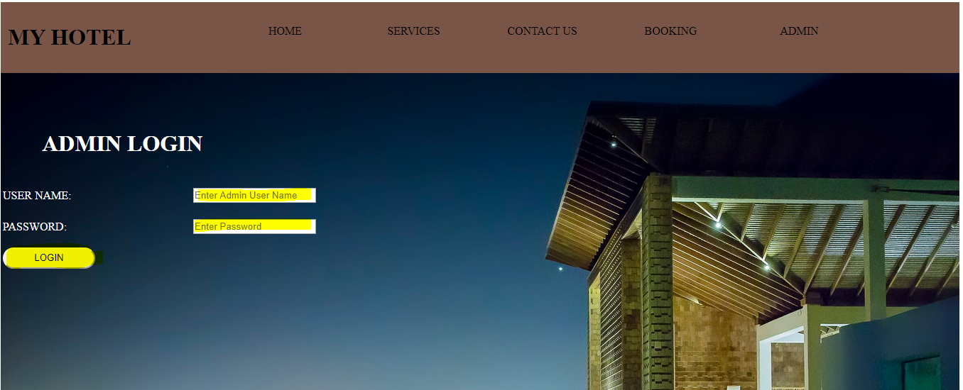

Admin Home Page

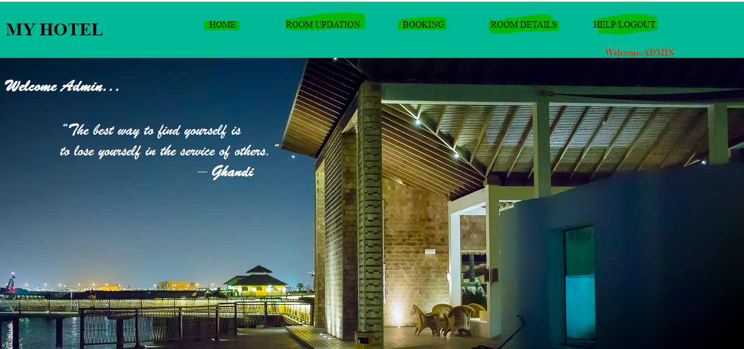

Adding new rooms to the hotels

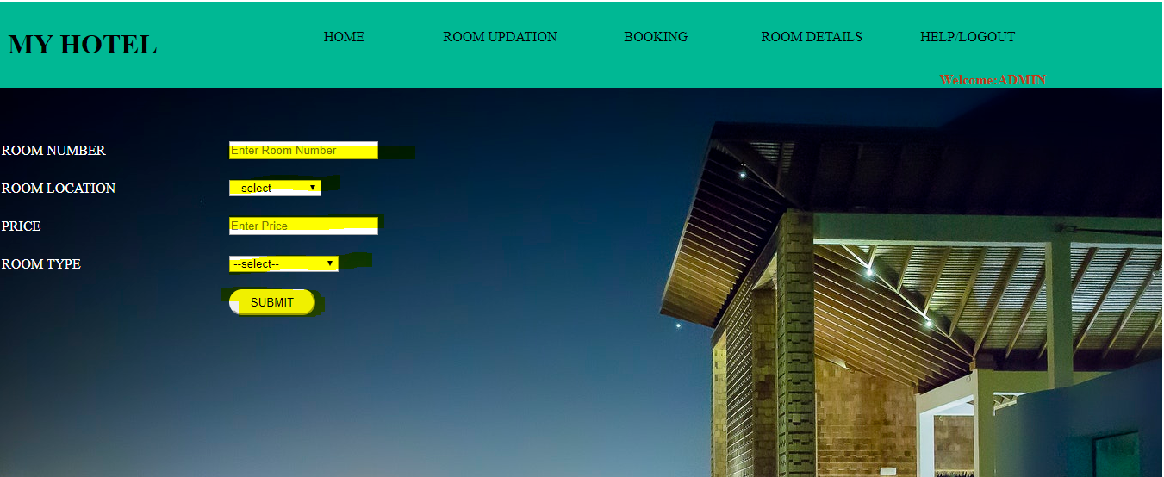

Viewing booked history of all customers:

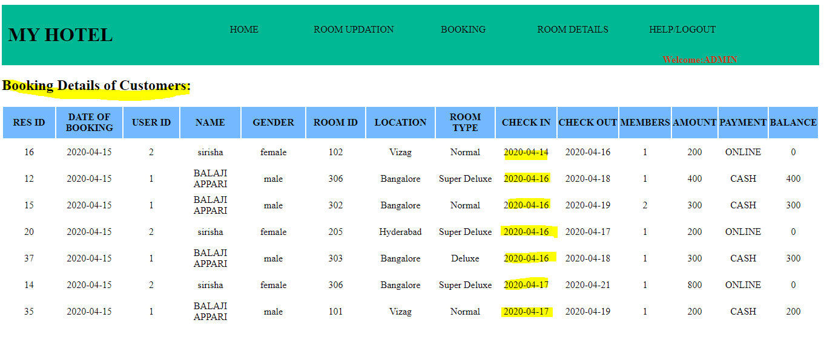

Hotel Room Details

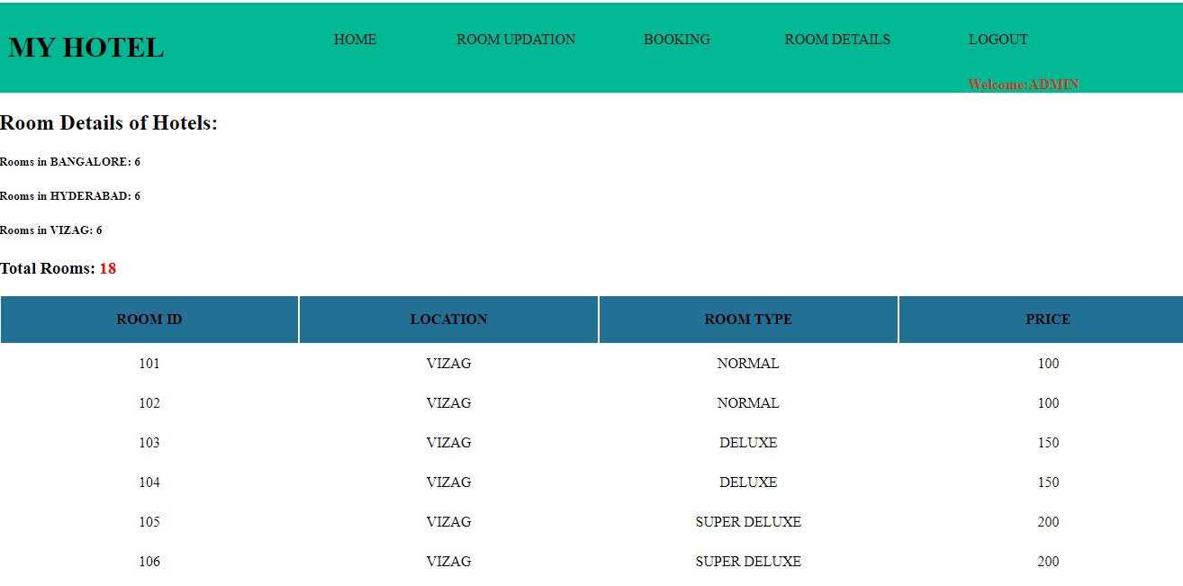

1. **Conclusion**

A basic database for the hotel system was created successfully using HTML, CSS, MYSQL and PHP. Where customers can book the hotel rooms and pay for it and cancel if necessary and admin can look at the progress and availability of rooms and can read the comments of customers.

1. **References**

* [https://www.w3schools.com](https://www.w3schools.com/html/html_css.asp).